CSA 1717-ARTIFICIAL INTELLIGENCE
LAB EXPERIMENT - 7
Abinaya Sri J(192524429)
AIM
To implement the Crypt Arithmetic Problem using the Backtracking technique in Python.
OBJECTIVE
To solve the Crypt Arithmetic problem by assigning unique digits to letters such that the given arithmetic equation is satisfied using the Backtracking algorithm.
ALGORITHM
Step 1: Start.
Step 2: Define the letters in the crypt arithmetic puzzle (SEND + MORE = MONEY).
Step 3: Generate all possible unique digit assignments (0–9).
Step 4: Assign one unique digit to each letter.
Step 5: Ensure that the first letters S and M are not assigned zero.
Step 6: Convert the letters into numbers (SEND, MORE, MONEY).
Step 7: Check whether SEND + MORE = MONEY.
Step 8: If the equation is satisfied, display the solution.
Step 9: Stop.

SOURCE CODE
# Crypt Arithmetic Problem
# SEND + MORE = MONEY
# Using Backtracking (Constraint Satisfaction)

letters = ['S', 'E', 'N', 'D', 'M', 'O', 'R', 'Y']
used = [False] * 10
assign = {}
def check():
S = assign['S']
E = assign['E']
N = assign['N']
D = assign['D']
M = assign['M']
O = assign['O']
R = assign['R']
Y = assign['Y']
send = 1000*S + 100*E + 10*N + D
more = 1000*M + 100*O + 10*R + E
money = 10000*M + 1000*O + 100*N + 10*E + Y
return send + more == money
def solve(index):
if index == len(letters):
if check():
print("\nSolution Found\n")
for ch in letters:
print(ch, "=", assign[ch])

S = assign['S']
E = assign['E']
N = assign['N']
D = assign['D']
M = assign['M']
O = assign['O']
R = assign['R']
Y = assign['Y']
send = 1000*S + 100*E + 10*N + D
more = 1000*M + 100*O + 10*R + E
money = 10000*M + 1000*O + 100*N + 10*E + Y
print("\nVerification")
print(send)
print("+", more)
print("------")
print(money)

return True
return False
letter = letters[index]
for digit in range(10):
if not used[digit]:
if (letter == 'S' or letter == 'M') and digit == 0:
continue
assign[letter] = digit
used[digit] = True
if solve(index + 1):
return True
used[digit] = False
del assign[letter]
return False
print("Searching for Solution...")
solve(0)

OUTPUT
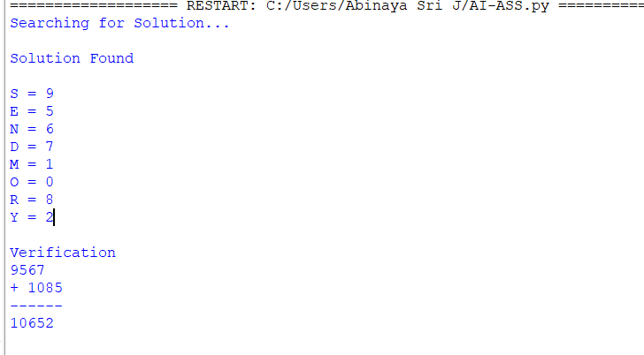
FLOW CHART
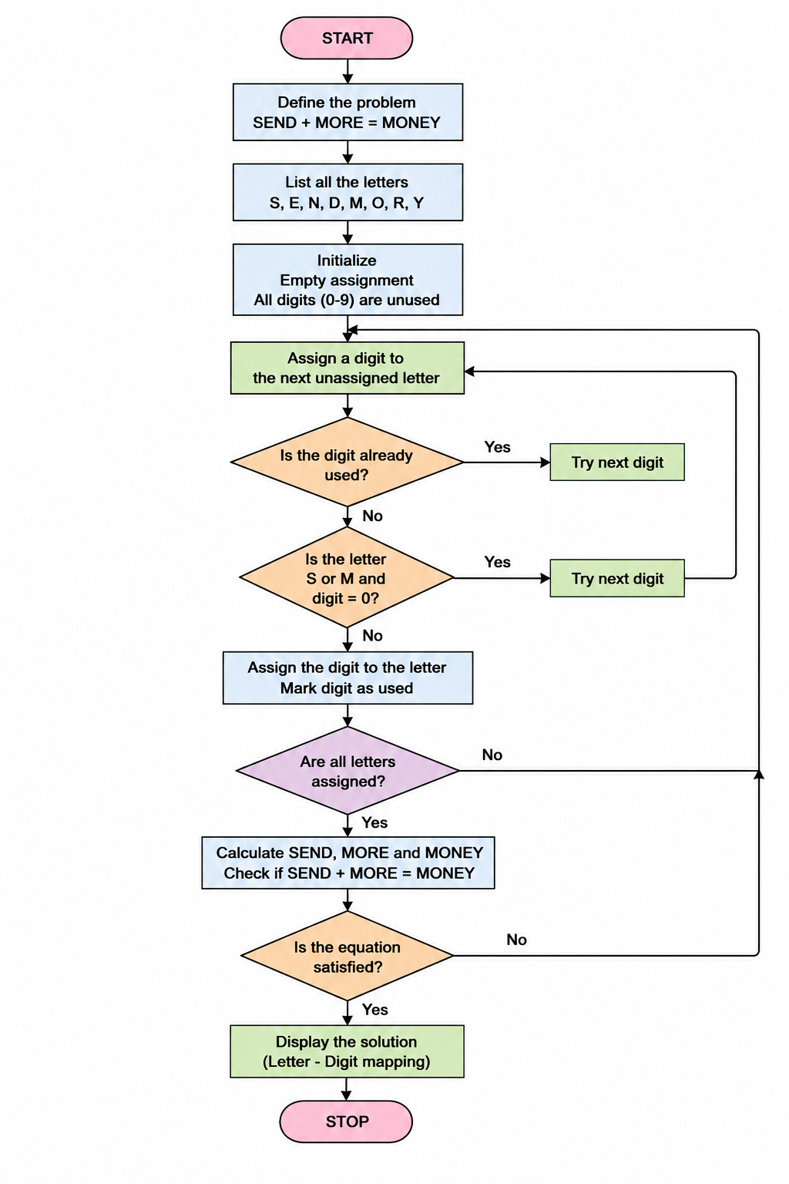

RESULT
The Crypt Arithmetic problem was solved successfully by assigning unique digits to each letter such that the equation SEND + MORE = MONEY is satisfied.

